“Київський фаховий коледж зв’язку”

Циклова комісія комп’ютерної та програмної інженерії

**ЗВІТ ПО ВИКОНАННЮ**

**ЛАБОРАТОРНОЇ РОБОТИ №4**

з дисципліни: «Операційні системи»

**Тема: “Команди Linux для управління процесами”**

Виконав(ла/ли) студент(ка/и)

групи: КСМ-23а

The Awkward Turtles:

Когут Б.М., Михайленко О.О.,

Трощинський Я.П.

Перевірила викладач

Сушанова В.С.

Київ 2024

*О.Михайленко:Я.Трощинський:*

*Я.Трощинський:*

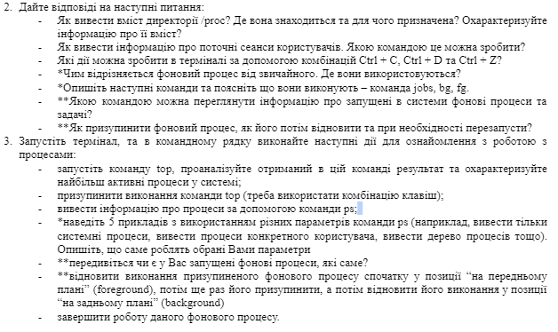

2. Answer the following questions:

* How to withdraw the content of the Directory /PROC? Where is it and what is intended for? Describe information about its content?
* How to display information about current user sessions. What team can you do?
* What steps can be taken in the terminal using Ctrl + C, Ctrl + D and Ctrl + Z?
* *How different is the background process from the usual one. Where are they used?
* *Describe the following commands and explain what they do - the Jobs, BG, FG command.
* ** With what command can you view the information about the background processes and tasks running into the systems?
* ** How to suspend the background process, how to restore it then and restart if necessary?

3.Run the terminal, and in the command line, perform the following steps to get acquainted with the work:

* Start the Top command, analyze the result in this command and describe the most active system processes;
* suspend the execution of the Top command (you need to use the key combination);
* deduce information about processes using PS command;
* *Give 5 examples using different PS command parameters (for example, display only system processes, deduce a specific user processes, deduce a process of processes, etc.). Describe what exactly the parameters you choose do
* ** Do you have advanced background processes, which ones?
* ** Restore the suspended background process first in the forecast position, then suspend it again, and then restore its execution in the background position
* complete the work of this background process.

2. - The directory /proc contains one subdirectory for each process running on the system it exists in the RAM. To see a content of the directory /proc I have written a command “ls /proc” and here what I got: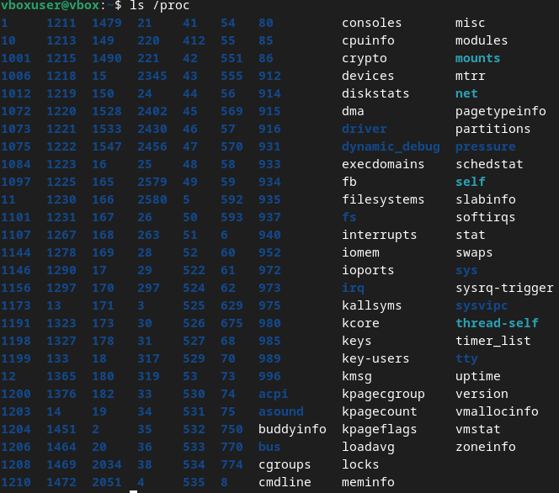

* To see what users are active right now I used a command “last -ap now”:

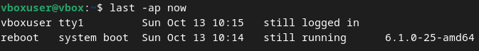

* If you use a Ctrl+C while having a command running, it will terminate.

If you use a Ctrl+Z while having a command running, it will suspend.

If you use a Ctrl+D after typing “sudo”, the terminal will be closed.

* Main difference between foreground and background process lies in who is activating it, if the activator is a user it is a foreground process, if it starts independently – it is the background one.

Background processes are used to do a operating systems.

* Using combination *command* &, you can make execution of this terminal command on the background, you can view progress and all of similar processes via using command “jobs”

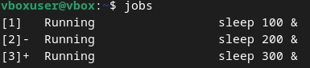

To move this processes from background to foreground(your terminal session) you can use command “fg %n” where n is number of job vice versa with using “bg %n”

* To see the list of background processes you need to type command “ps -e”.
* To suspend and re-enable any process using terminal you need to do a sequence of actions:

“top”/”pf -e”

find your process ID(PID)

“kill -19 *PID*” // your process is suspended and if you use a window of it, it will crush

“kill -18 *PID*” // process if normal now

3. - After using the command “top” I see a lot of things, from what I can see there about half of them are intuitively discoverable.

1. Total number of tasks
2. Total amount of active users
3. Process ID(PID)
4. Executing user of process
5. Priority
6. Name/directory of command

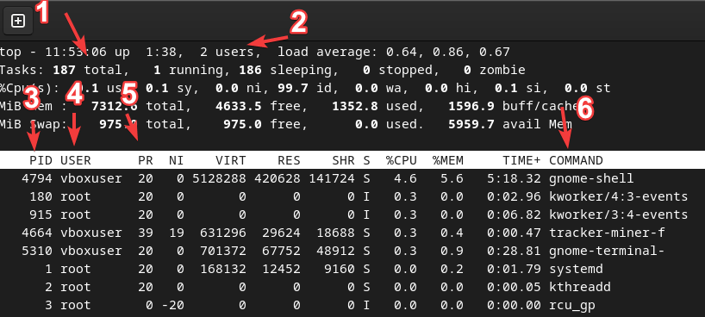

* To leave this table you need to tap “Q”, “Ctrl + Z”, or “Ctrl + C”.
* To see all root processes you need to type “ps -u root”

To see all user processes you need to type “ps -u *username*”

To see process tree you need to type either “ps -ef” or “pstree”

To get info about threads you need to type “ps -eLf”

To get info about needed process you need to type “ps -p *PID*”

* Using command “ps -e” I see a lot of background processes, roughly 500. I have processes of: system, gnome-shell, web content, gnome-terminal.
* 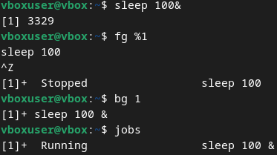
* To kill this job-process we can use 1 of 3 methods:

1. “fg %1” “Ctrl + C”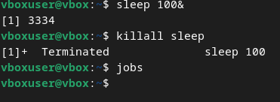
2. “kill -9 *PID”*
3. “killall *command*”

I used the third method:

*Б.Когут:*

**Control Questions:**

1. **What is the purpose of the /proc directory in Linux systems? What information does it store?**

The /proc directory is similar to the /dev directory because it contains not ordinary files but special files that provide information about running processes and the state of the kernel. The contents of the /proc directory are used by various utilities to obtain system information at runtime.

For example, if you want to check information about the processor in Linux, you can simply refer to the file `/proc/cpuinfo`. If you want to check the memory usage of your Linux system, look at the contents of the file `/proc/meminfo`.

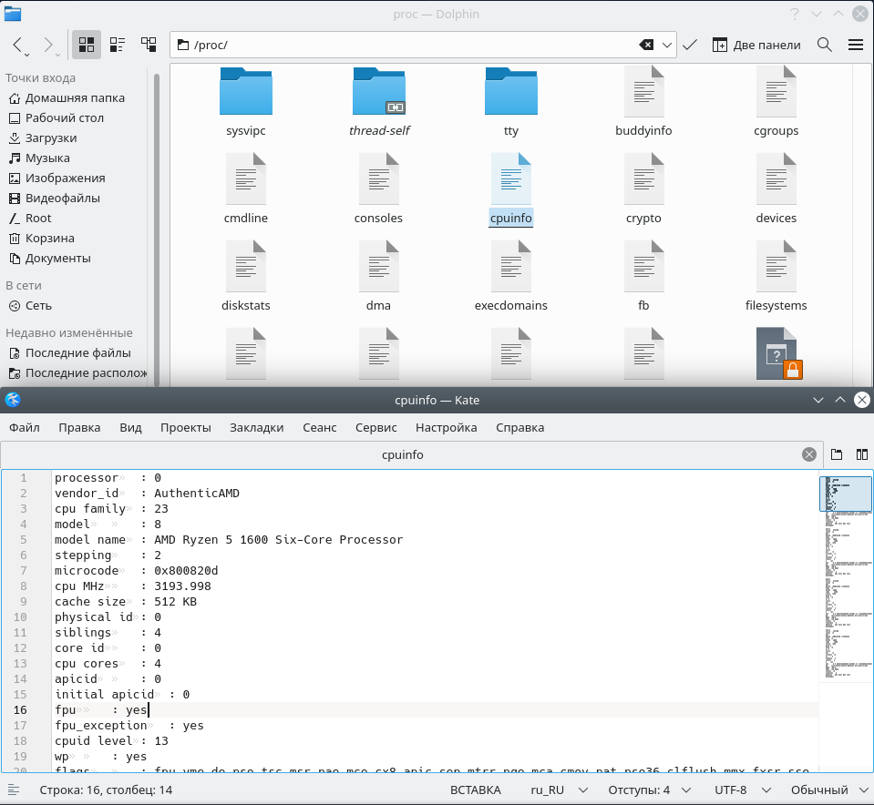

2. **How can you dynamically determine which of any three processes is currently using the most memory? What percentage of memory does it consume from the total?**

To see which processes are currently running, use the `ps` command, but it only shows the launched processes. You can also use the `ps` command with `head` and `grep` to filter the processes you want to display.

For example: `ps -e | grep <program name>`

The `top` command will show the currently running processes dynamically, regularly updating the process data.

3. **How to get the hierarchy of parent processes in Linux systems? Describe its structure.**

You can view the hierarchy of parent processes using the `pstree` command. It works like this: one process starts another process; the first process is called the parent process, and the second process is called the child process.

4. **What is the difference between the top and ps commands?**

The `ps` command shows the currently running processes, while the `top` command shows dynamically running processes.

5. **What additional features does htop implement compared to top?**

The main difference between `htop` and `top` is that `htop` shows the same information as `top` but presents it in a more user-friendly interface, filtering them and providing more detailed information about the processes.

6. **Describe the components of your mobile OS for monitoring running processes in the system.**

Typically, in a mobile operating system, the following are used for monitoring running processes:

Task Manager: Displays all active applications and processes.

OS Kernel: Controls low-level process management, ensuring scheduling and resource management.

System Monitor: Tools that provide detailed information about resource usage, such as CPU, memory, and network connections.

7. **Does your mobile OS support terminal management of process operations? Describe how.**

Android supports terminal access through the ADB command interface, allowing users to view running processes, terminate them, or change their priorities. For example, the `ps` command can be used to view processes, or `kill` can be used to terminate them.

8. **Is it possible to install third-party software tools that allow you to manage and monitor the operation of processes on your mobile phone? Briefly describe them.**

Yes, it is possible on Android to install third-party applications for process monitoring, such as System Monitor, Termux, and Greenify.